**Anypoint Studio V7.14.0**

**Mule Runtime V 4.4.0**

Introducing the course

Tools Required:

1. Anypoint Platform Account(Web based Tool)-------- http://anypoint.mulesoft.com/
2. Anypoint Studio(An IDE)----- https://www.mulesoft.com/lp/dl/studio
3. Postman or Advanced Rest Client(Rest Clients for Testing the APIs)
4. Course File from the course resources sections

To check Anypoint Trial Subscription Expiration Date:

Login to anypoint platform->Access Management->Under subscription choose “Runtime Manager”

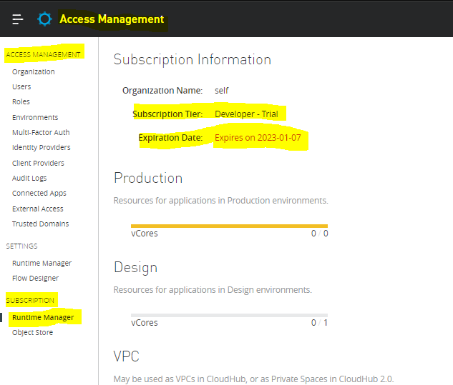

# 1 - Introducing application networks and API-led connectivity

IT Delivery Gap:

Today we have so much gap between what IT can deliver and what IT is delivering.Since technology changes is happening day-by-day so it’s becoming a huge gap between what IT is expecting to deliver and what IT actually is delivering to customers.

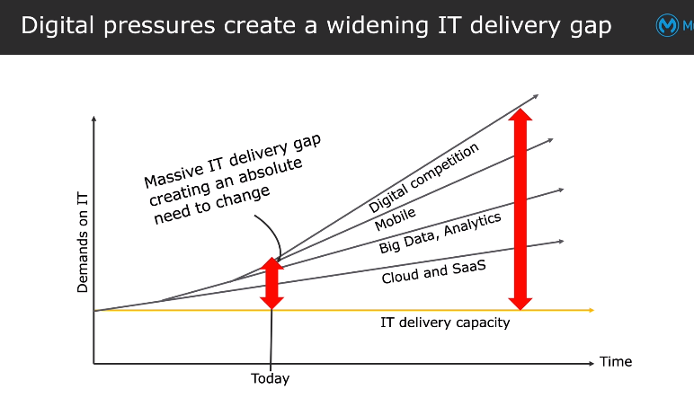

New Approach:

IT Delivery Gap increasing not only becoz of Technology changes but also it’s related to the operating model of org,execution of business n org structure…To fill up this IT gap,an org can operate in a new way, can execute business process and forming a cross functional team(C4E=center for enablement) in such way that IT gap can be filled up.

By saying adapting to New operating model means adopting a new delivery model like production+Consumption model….before this we were just producing the assets n if any new requirement comes then we were producing another asset ,i.e called as production model ……but production+consumption model means after we got requirement, instead of going for producing gnew asset ,we can search for asset that is already built n can be used for solving the newest requirement i.e called as Production+Consumption model which promotes to build reusable assets+ consumption of reusable assets.

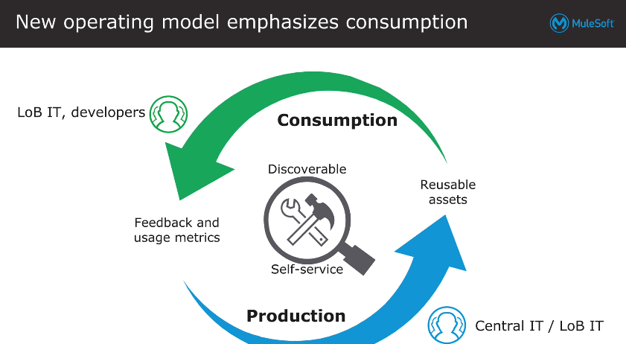

By saying adapting a new way to execute business process means changing the integration approach…. instead of using traditional approach(Monolithic Approach) for building assets where systems were tightly coupled and if any changes are there in one system,it is directly affecting the whole integration. .the new way of integration which uses microservices approach n where we integrate using APIs by using API-led connectivity which has 3 API Layers called as system API,Process API,Experience API etc . where actual system(Target System) interaction is exposed only thru the System API n all other transformations,filteration+business logic was covered in process layer n if a consumer wants the response format in other format than the response format provided by process API then we can include that logic in experience layer. 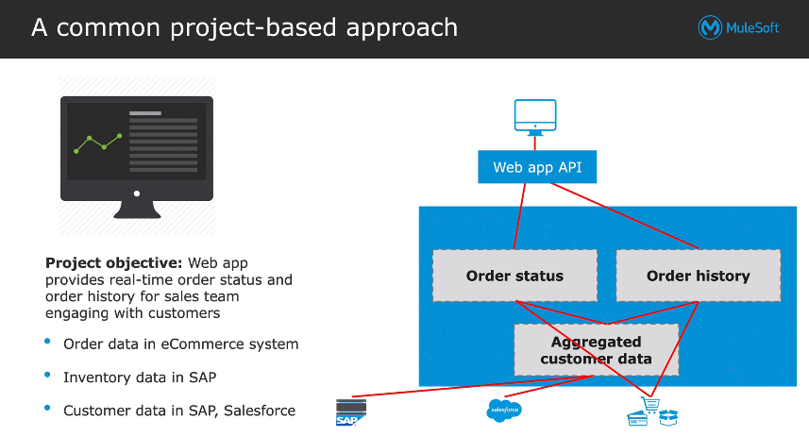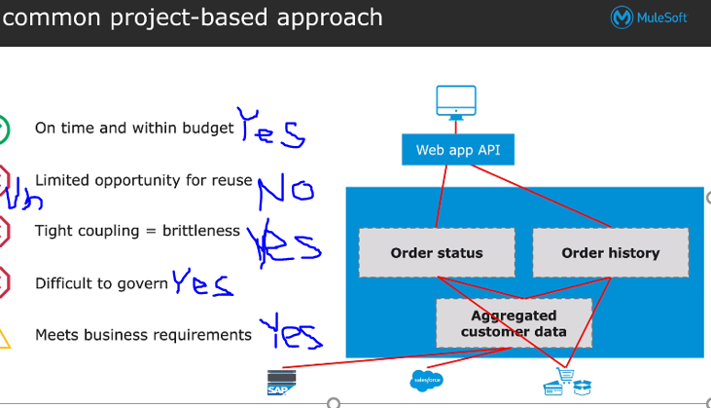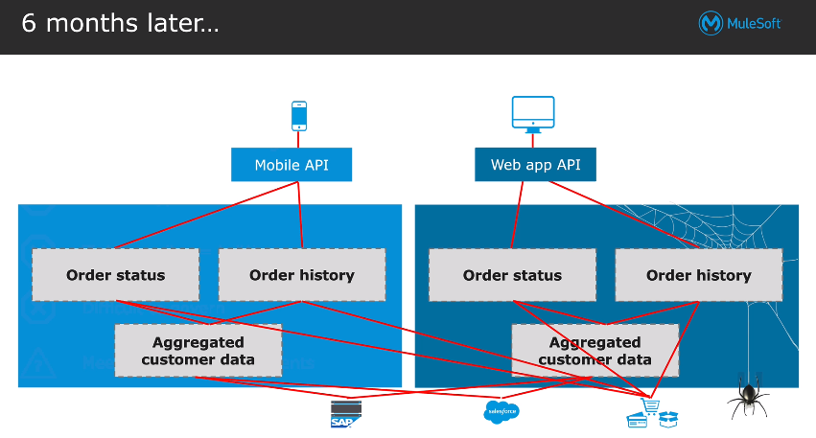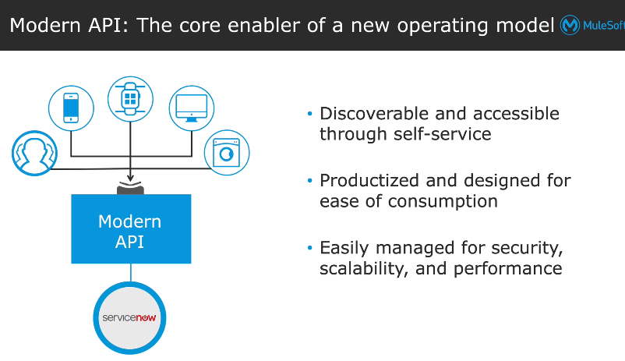

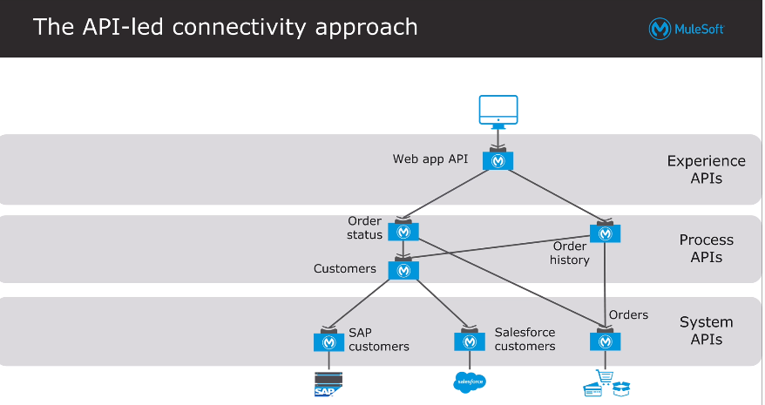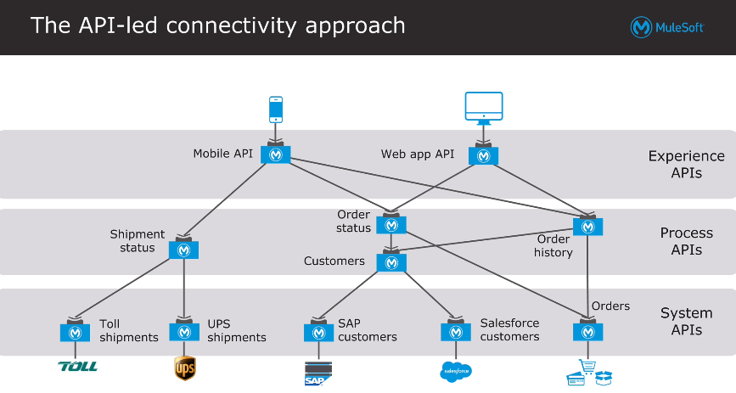

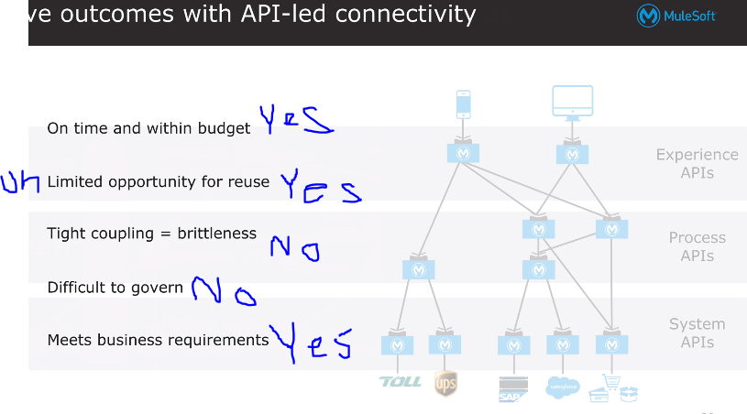

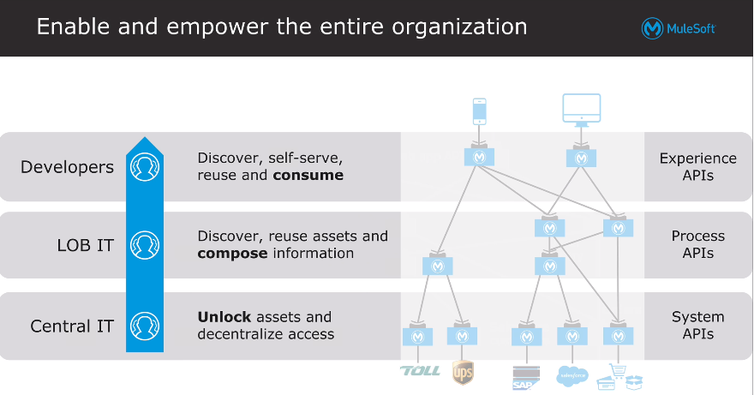

By saying adapting a new way of org structure (IT) means that forming a cross functional team(C4E=center for enablement) which is a team dedicated to enabling the organization to consume and get full value from the assets. It is typically staffed with members from Central IT, Line-of-business departments, and digital innovation teams and is charged with productizing, publishing and harvesting reusable assets and best practices. They promote consumption and collaboration, and help drives self-reliance while improving delivery through feedback and metrics. It captures the notion that there is balanced deployment approach to each project. The team decides if the project can use a reusable asset and if it should create reusable assets for future projects or if it is a one-off project. The name might sound similar to an older concept — the Center of Excellence (CoE). However, C4E is a radically different idea. A traditional CoE would feature centralized expertise and knowledge, which would result in information being protected and rationed. CoEs often become bottlenecks which make developers and architects work around them. In contrast, the C4E model focuses on putting valuable assets in the hands of development teams across the organization, encouraging them to not only utilize the assets but add and improve assets as well. As projects are initiated and developed, a core set of assets such as APIs, templates, common platform capabilities, like logging, caching and error handling as well as documentation, code samples, videos, become the initial asset base for the C4E. These assets must be productized for self-service consumption and published to a central repository like Anypoint Exchange so the assets can be discovered and utilized. Then, as new projects come along (like the order status web application described earlier), the C4E will engage those project teams and encourage collaboration and reuse of existing assets. As the asset base grows, developers on the innovation teams throughout the organization can be self-reliant. They can find those assets, accelerate the development of their mobile app, add their own API assets for shipping information and feed that capability back to the C4E. This shows the multiplicative power of the community and its concomitant effect on IT delivery capacity.

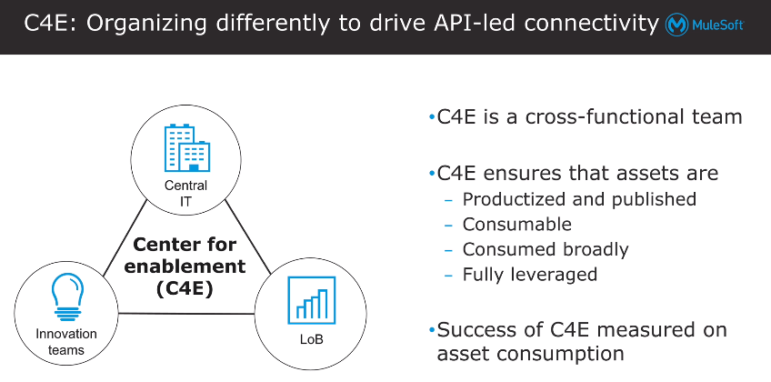

Application Network:

By following all the above mentioned three changes we get an network of applications,data,APIs created

Let say we have an org. called suryastra in which we have below apps or systems so when we adopt the above 3 changes n start with the 1st project, we create applications network where multiple apps are connected with APIs.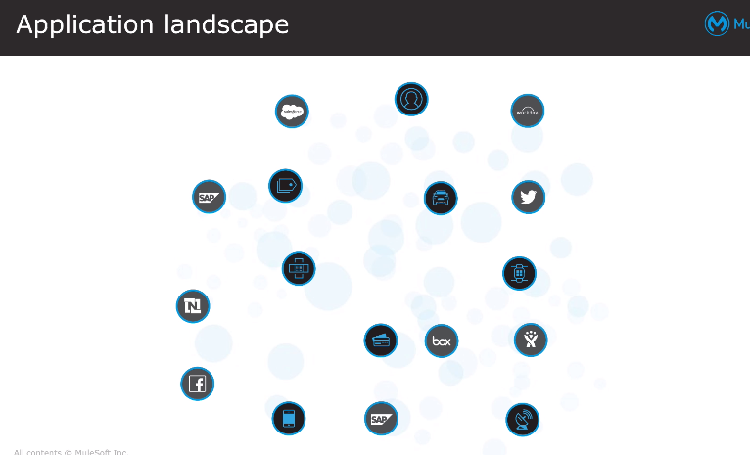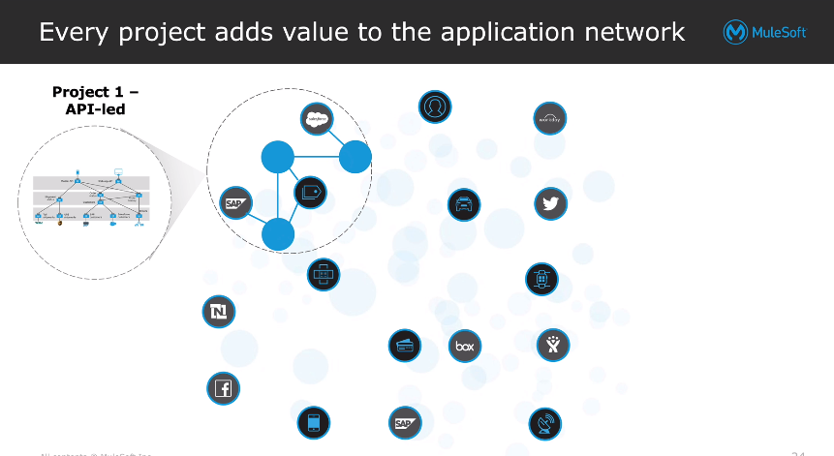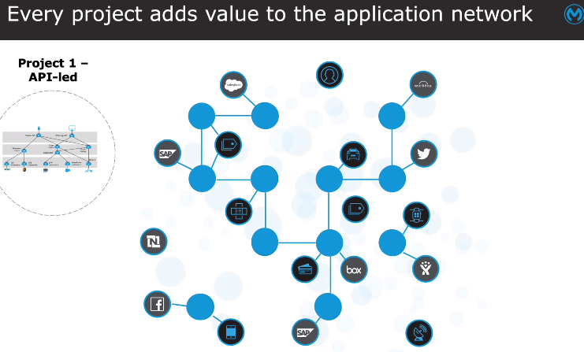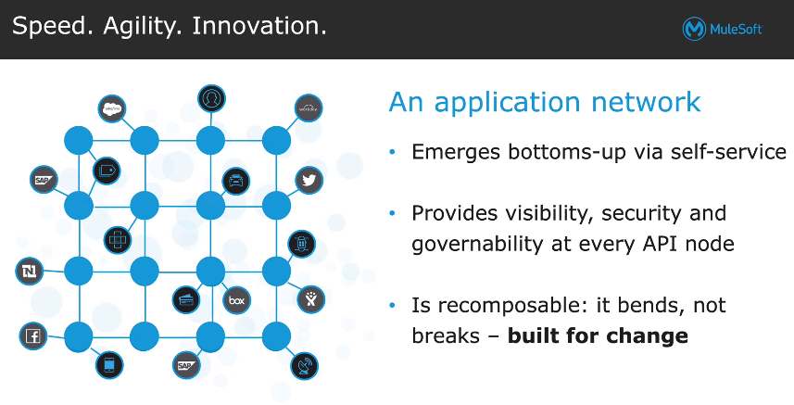

API:

API is Application Programming Interface which helps to create a communication between 2 systems.it has operations or methods(what to call) ,inputs(request params),outputs(response) 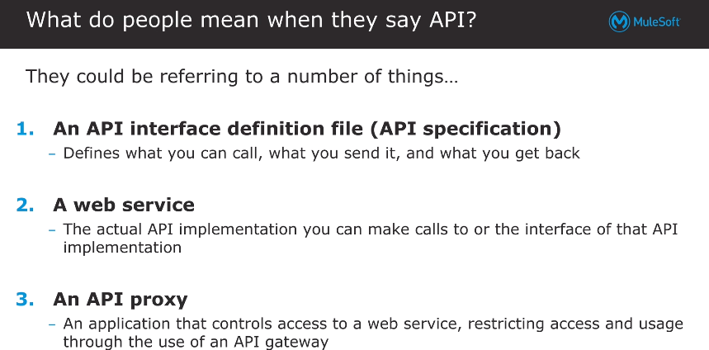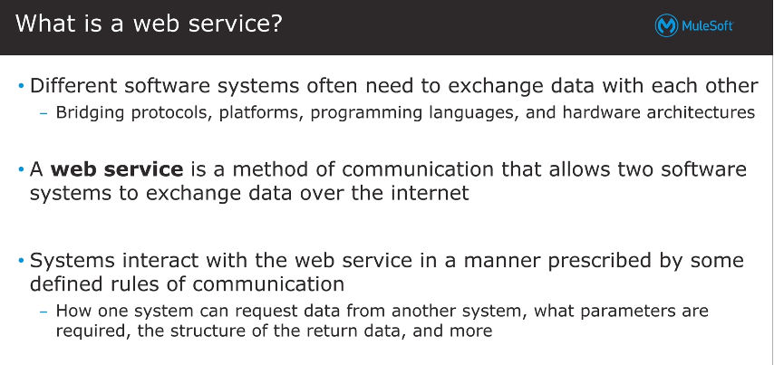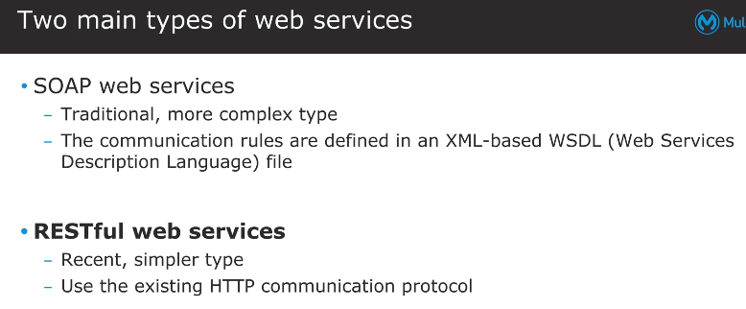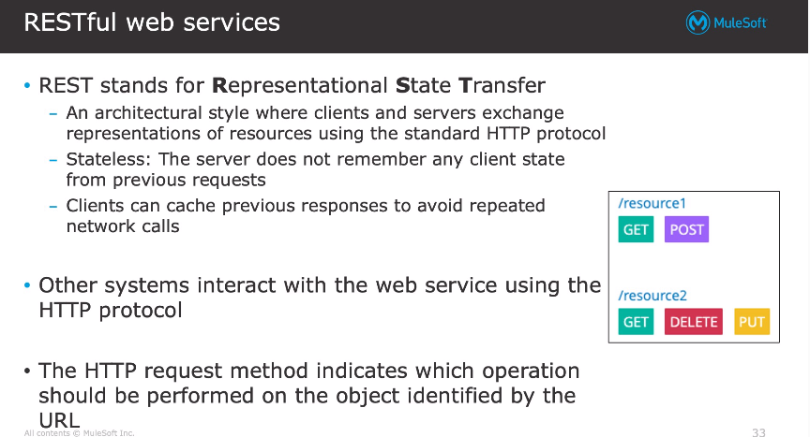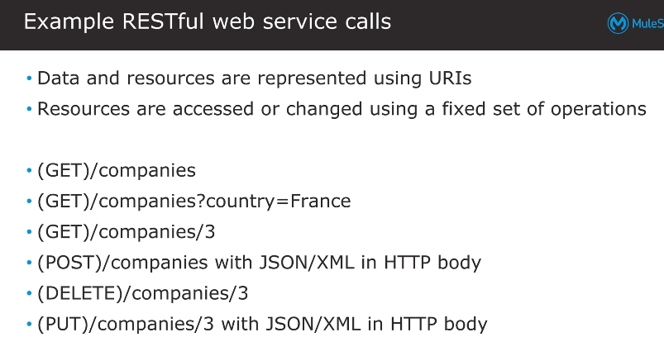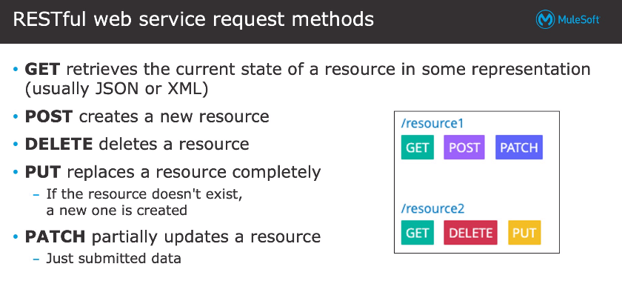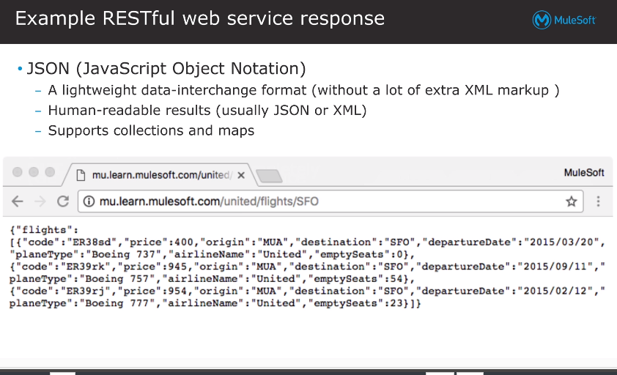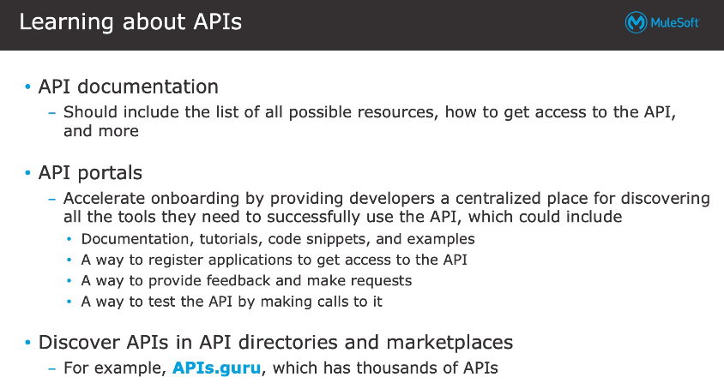

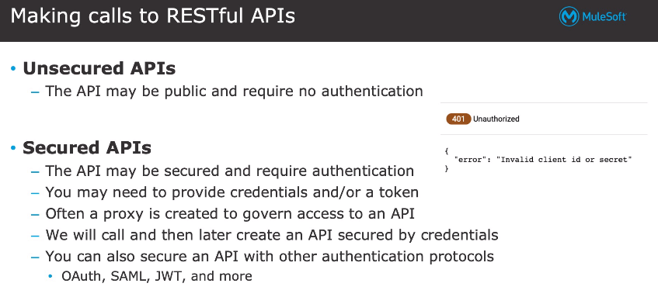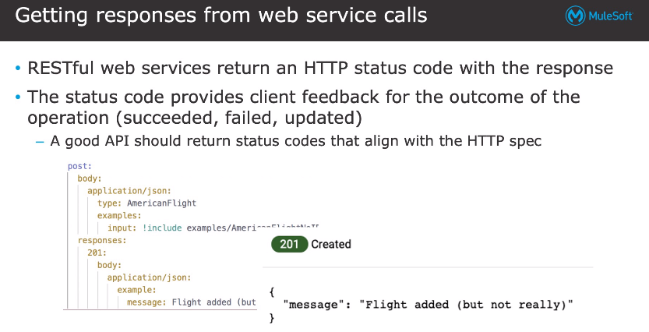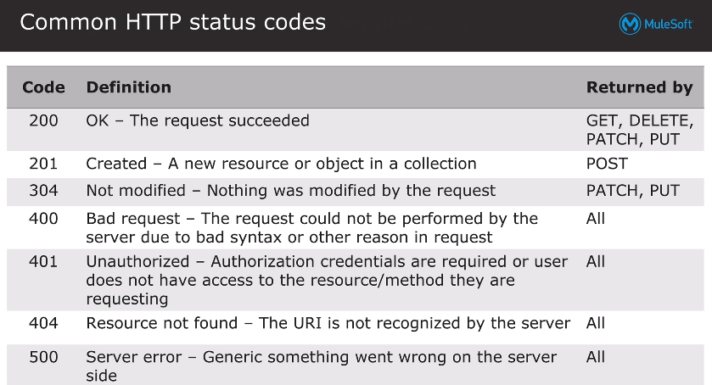

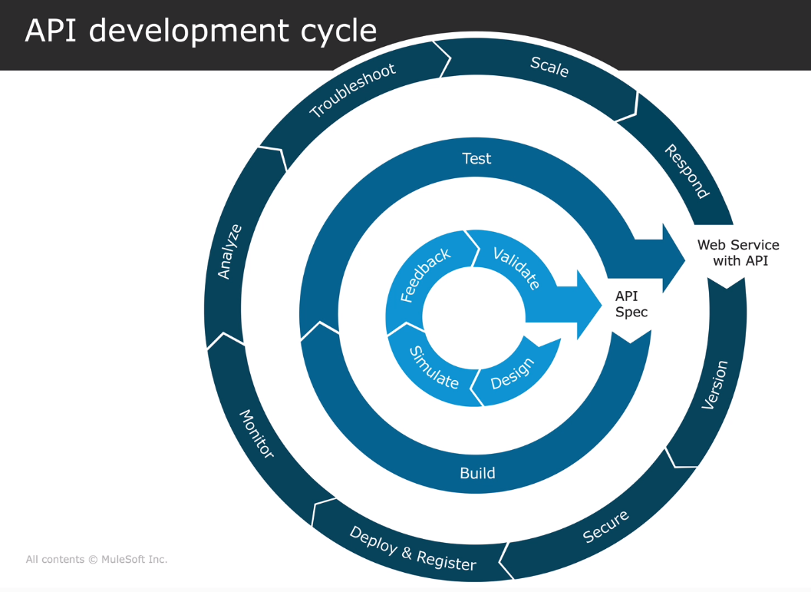

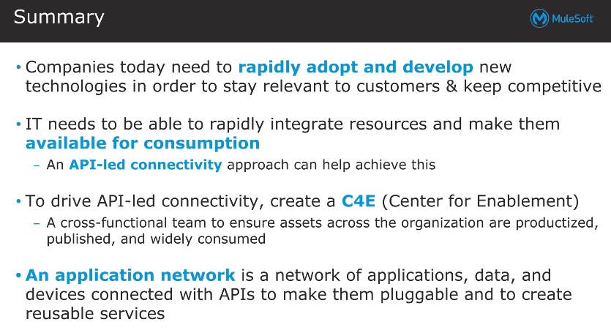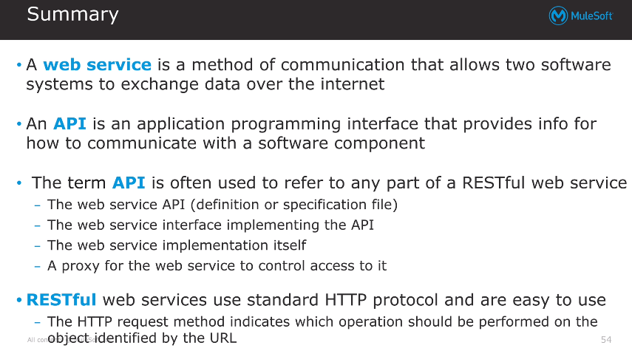

# 2 - Introducing Anypoint Platform

Anypoint Platform:

Anypoint platform is a Web-based tool which has Cloudhub-An IPass(Integration-Platform as a service) solution which helps to integrate cloud as well on-prem systems with each other n with self(cloud-cloud,onprem-onprem).It helps to build,design,consume,control,govern,deploy,test API n used to create Application networks.It has design center,Exchange,Runtime Manager,API Manager,Access Management etc.

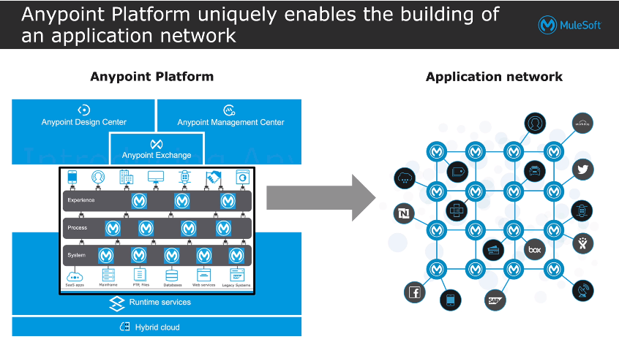

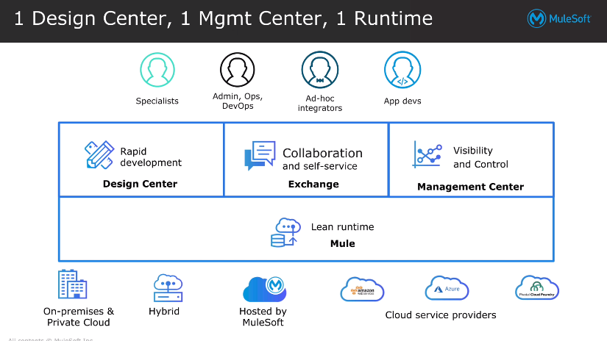

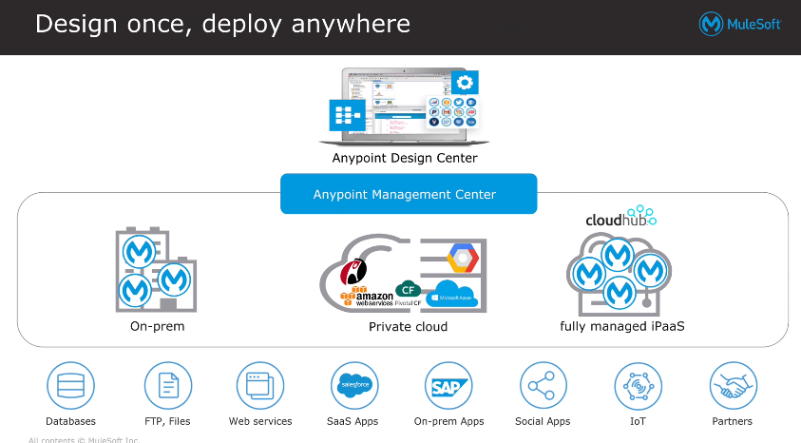

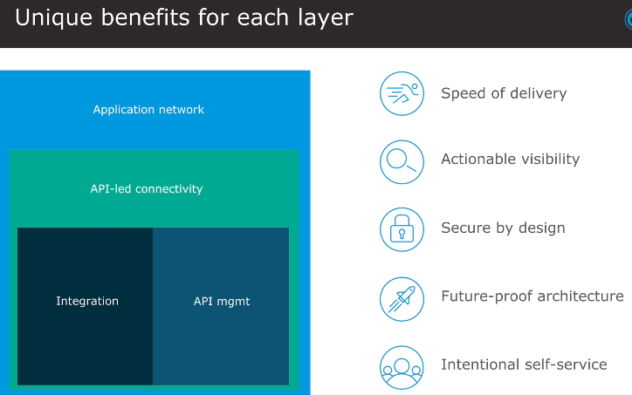

Achieving success with Mulesoft Catalyst:

For achieving success an org. should follow the approach mentioned in the mulesoft catalyst approach.

Mulesoft catalyst has 3 pillers:

1. Business Outcomes (all stakeholders should identify n be aligned with outcomes.)
2. Technology Delivery (An org IT team should be ready to deliver the integrations using anypoint platform)
3. Organizational Enablement (An org. should be able to ready for adopting anypoint platform.)

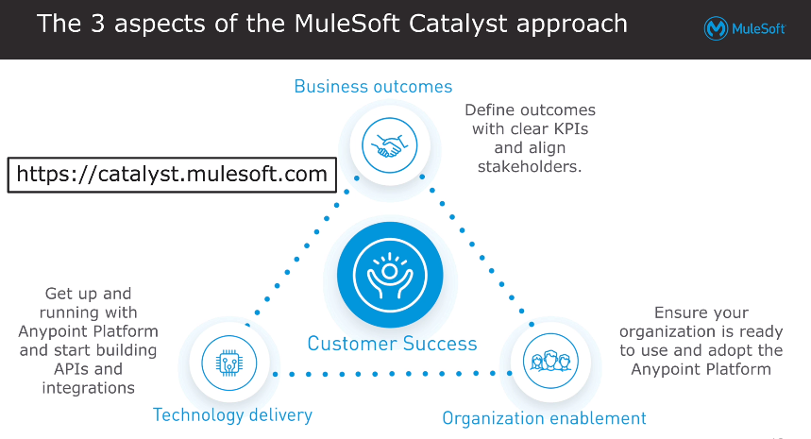

3 Pillers are divided into 6 Playbooks which describes best practices:

Business Outcome has 1 playbook

1. Business Outcome

Technology delivery has 2 playbook

1. Anypoint platform
2. Projects

Organizational Enablement has 3 playbooks

1. C4E
2. Internal Support
3. Training

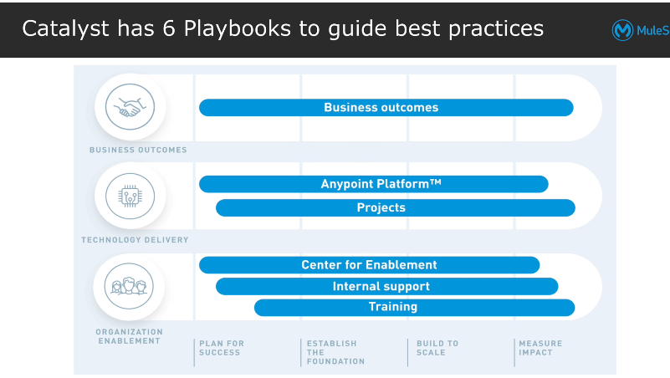

The 6 Playbooks has 4 steps/paths defined

1)plan for success

2)Establish a foundation

3)build to scale

4)Measure Impact

This approach has 30 steps in blueprint which provides a way to achieve success defined across 3 pillers’s 6 playbooks in 4 paths

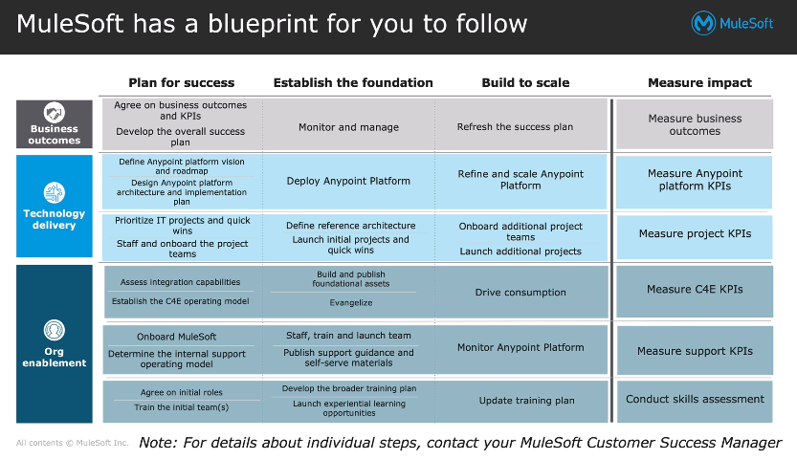

Components of Anypoint platform:

Anypoint platform offers many components which can be used in the lifecycle of developing an API.so as API Development Lifecycle has below steps

1. Design (involves design,stimulate,feedback,validate etc. which results into API Spec)
2. Implementation (involves Build n test which results into Web service with API)
3. Management (involves secure,deploy,monitor,troubleshoot,analyze,scale,respond)

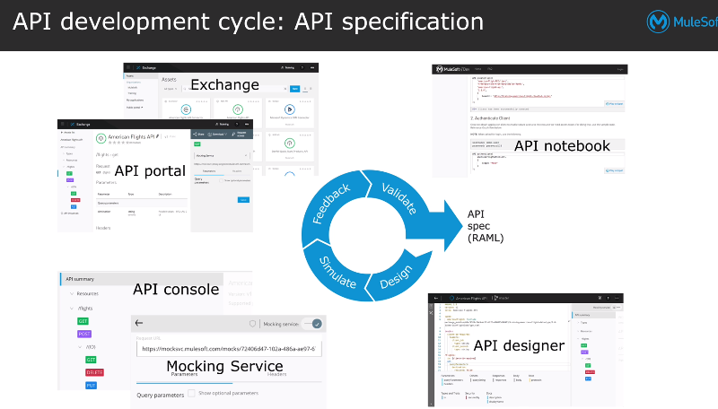

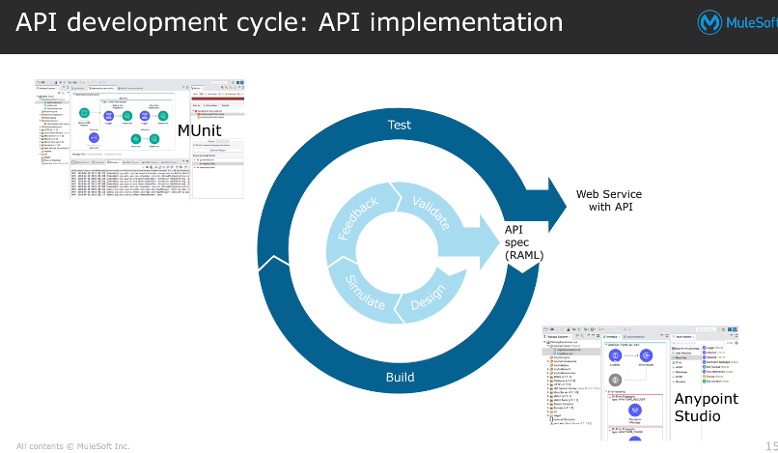

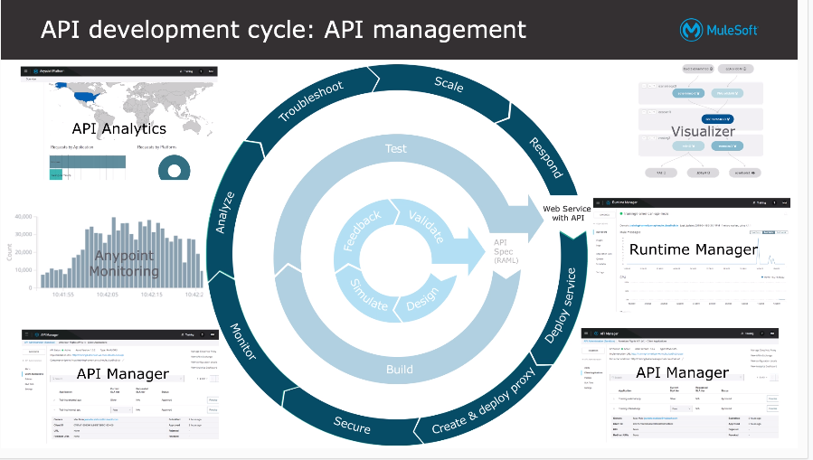 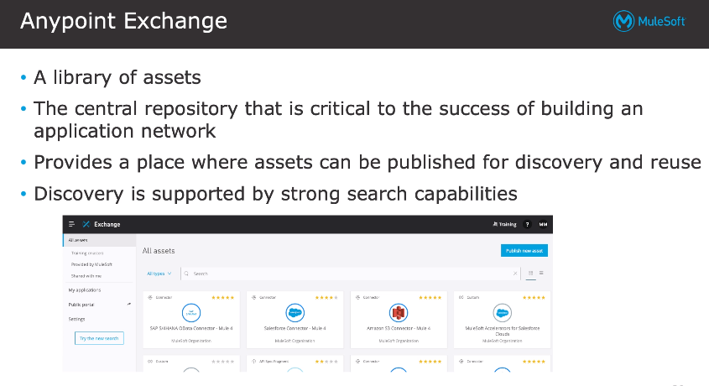 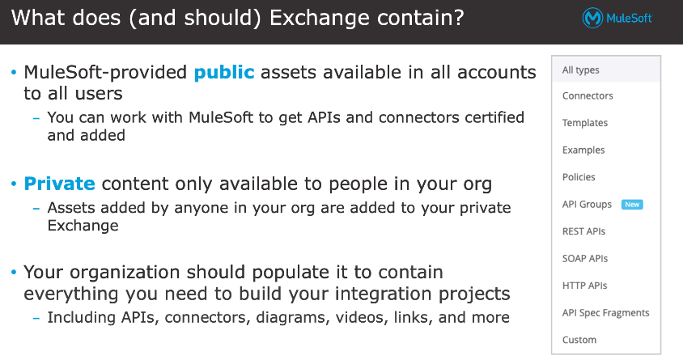 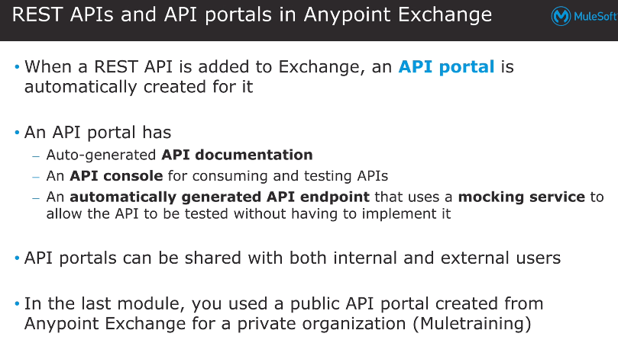 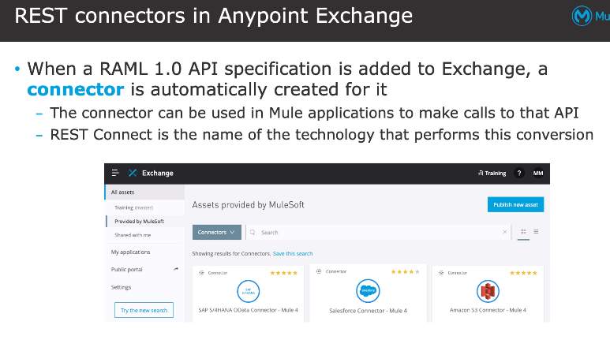 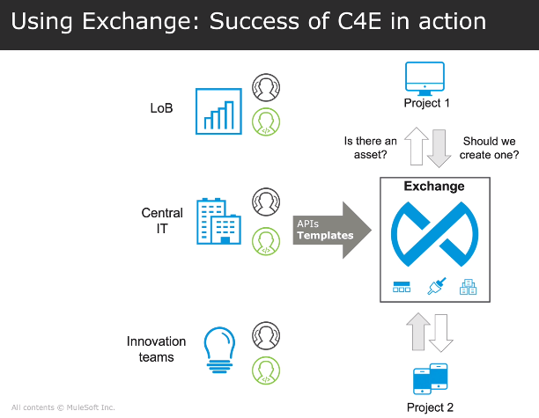

Building integration applications and APIs with Design Center:

Design center helps to create mule-integration apps,api specifications,api fragments,async apis etc.

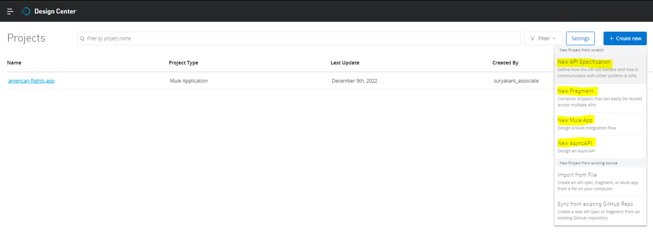

To create Mule-Integration App, Design Center provides Flow Designer tool

To create API Specifications,Design Center provides API Designer Tool

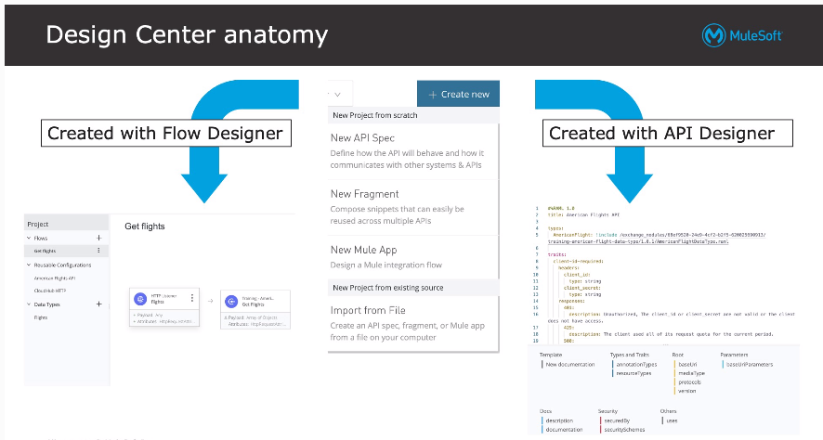 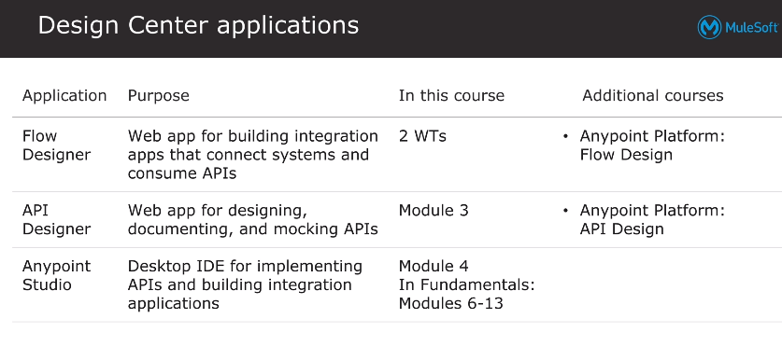

Mule-Integration Applications:

Mule-integration apps are built using Anypoint studio or Flow Designer and both Anypoint studio or Flow Designer arebuilt on java framework called “Spring”.Mule apps works on events where they listen the event ,process them n route them to other endpoints.

Note:A empty mule-project (where no flow declaration is created)created in anypoint studio can be successfully built n deployed

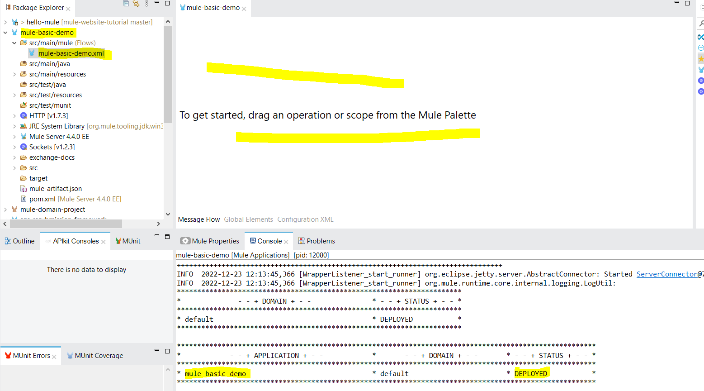

Flow:

Events are captured and processed by mule-processors which can be defined in a Flow.

Flow has 3 sections :

1. Source (Triggers or listens to an event)
2. Process (Processes an Event)
3. Error Handling (Handles the Error if exists)

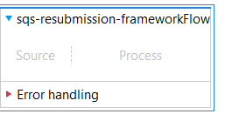

Note:

1. An Empty flow like above pic decalred in mule project will failed to build n deploy.
2. A Flow needs to have atleast 1 mule-procesor in Process section to successfully build n deploy the the mule app…. 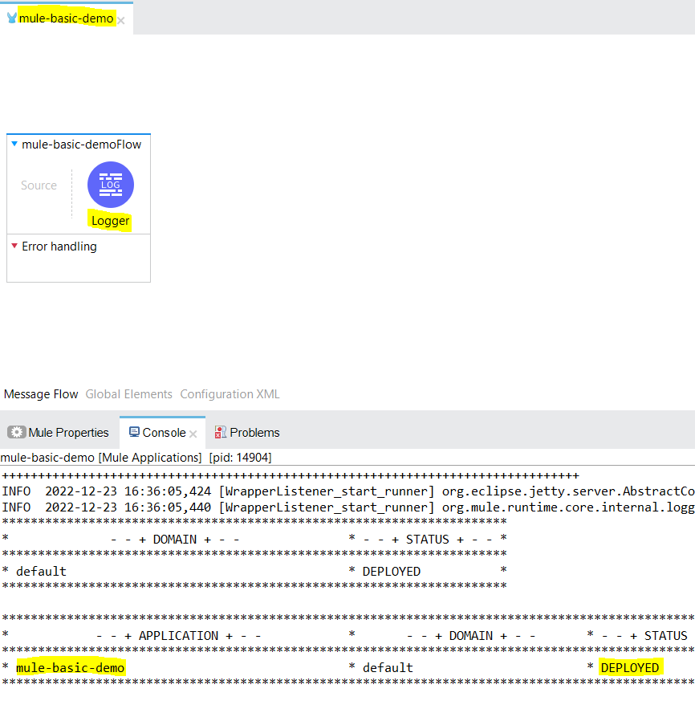
3. A flow with only source component or a flow with only error-handling component declared or a flow with both source component and the error-handling component declared will be failed to build n deploy becoz in any case we have Flow’s process section as Empty…. 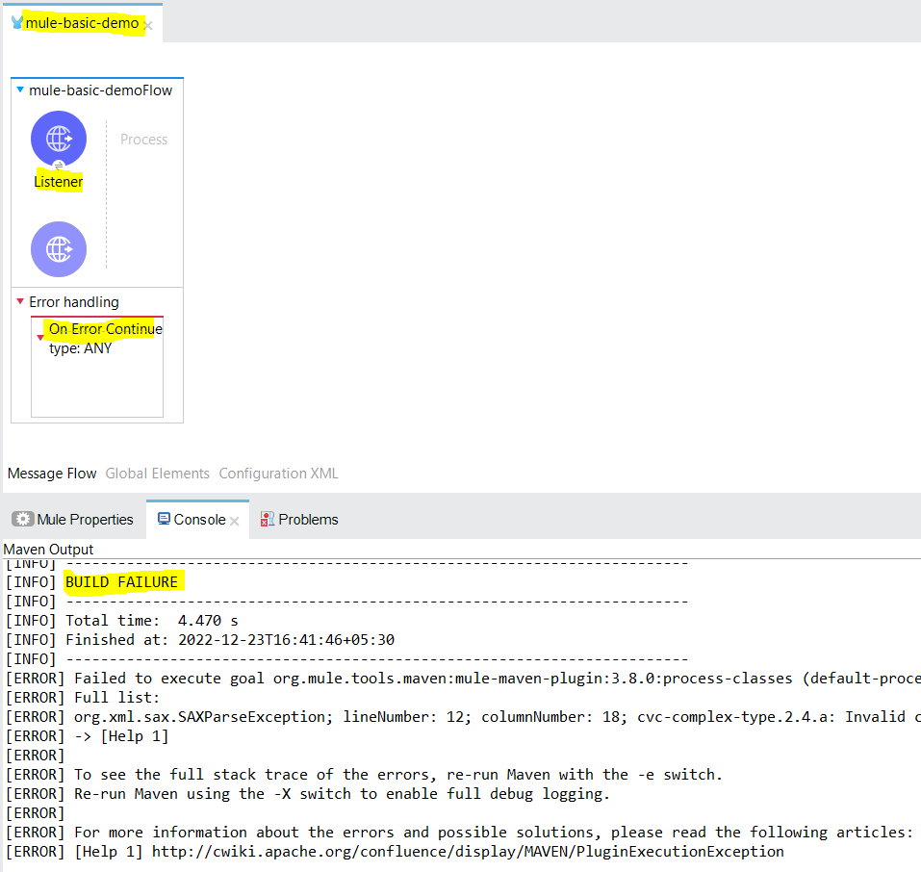
4. So that’s means a flow should have a mule-processor declared in a process section of the Flow,then only project will get build n deploy successfully

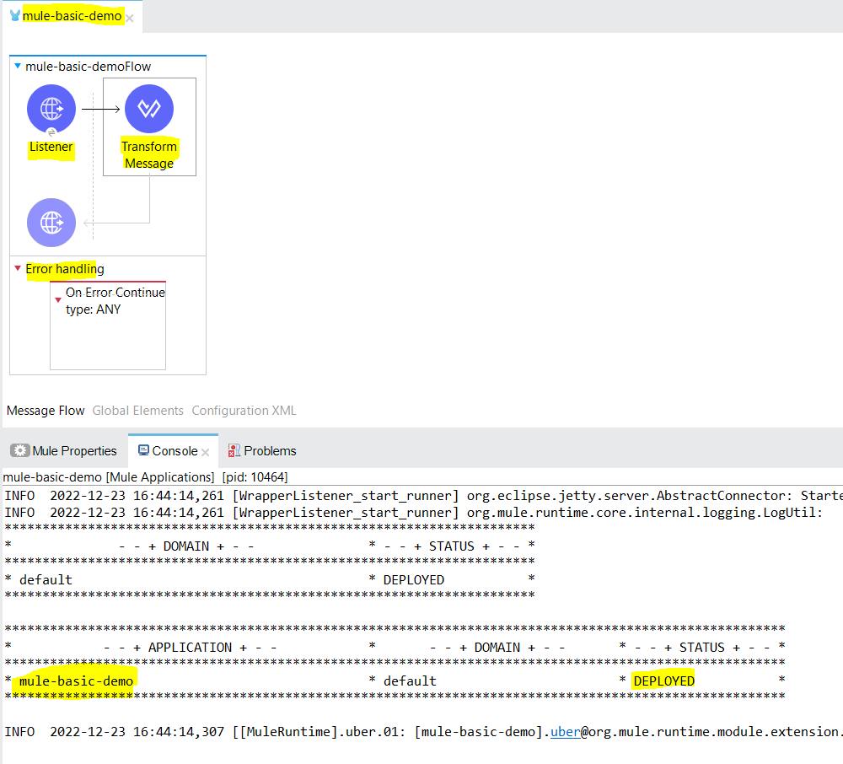

1. A project can have single flow or multiple flows or single or multiple sub-flows but make sure every flow/subflow has atlease 1 mule-processor declared inside process section to successfully build n deploy the project.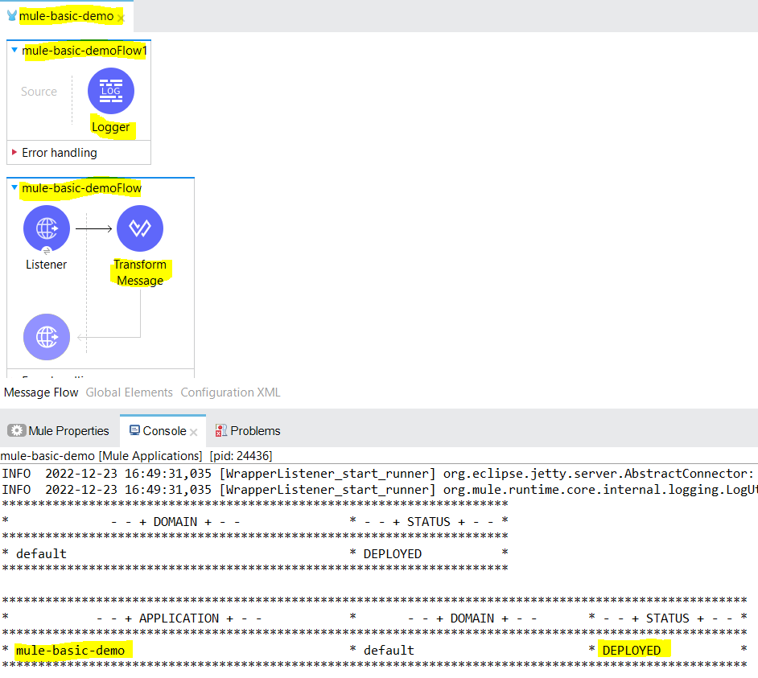 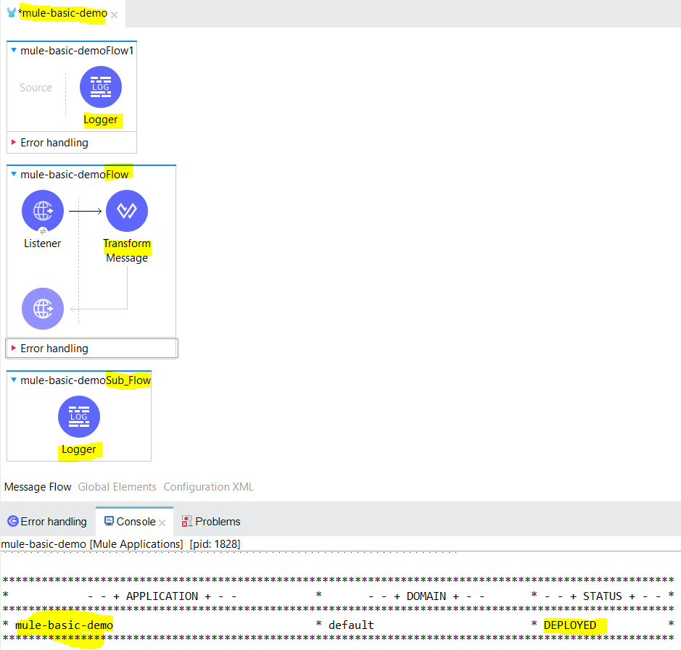
2. A Flow’s/sub—flows/private flow’s proceessor’s declared inside process section processes in a synchronous mode ….to make those to process in async mode(Fire n forget) we can use async scope.

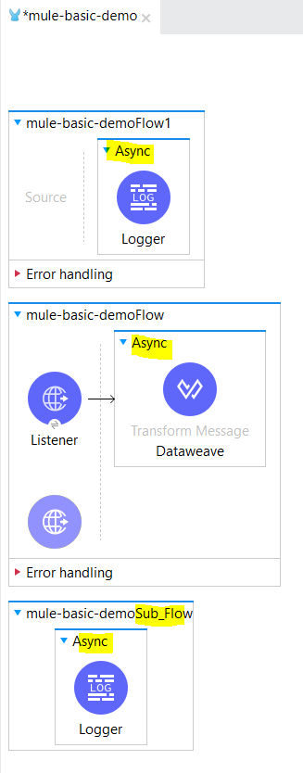

Sub-flow:

A sub-flow is a flow without the source,error-handling section in it…to have error handling in it we can use Try Scope.A sub-flow has only process section in it.

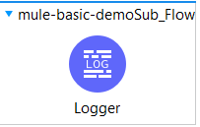

Private-flow:

A Private-Flow is similar to Flow which don’t have any source declared in it.

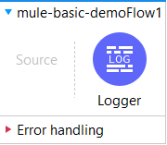

Note:

1. Both Private n sub-flows should have atleast 1 mule-processor declared inside the process section otherwise project will fail to build n deploy…
2. We can call another flow or sub-flow or private flow from a flow using flow-reference component. But with Dataweave language we can call only a flow or private-flow from a flow using dataweave code by using lookup fuction…We cant call subflow from lookup function we get an error at runtime .

## Syntax: lookup(flowName: String, payload: Any, timeoutMillis: Number = 2000)

Example:

lookup('flow2', {“test”: “hi”},4000)

| **Name** | **Description** |
| --- | --- |
| flowName | A string that identifies the target flow. |
| payload | The payload to send to the target flow, which can be any (Any) type. |
| timeoutMillis | Optional. Timeout (in milliseconds) for the execution of the target flow. Defaults to 2000 milliseconds (2 seconds) if the thread that is executing is CPU_LIGHT or CPU_INTENSIVE, or 1 minute when executing from other threads. If the lookup takes more time than the specified timeoutMillis value, an error is raised. |

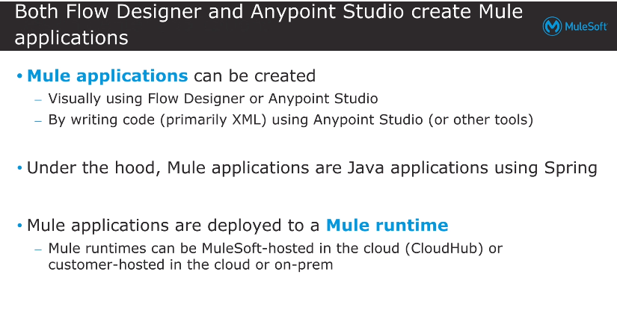

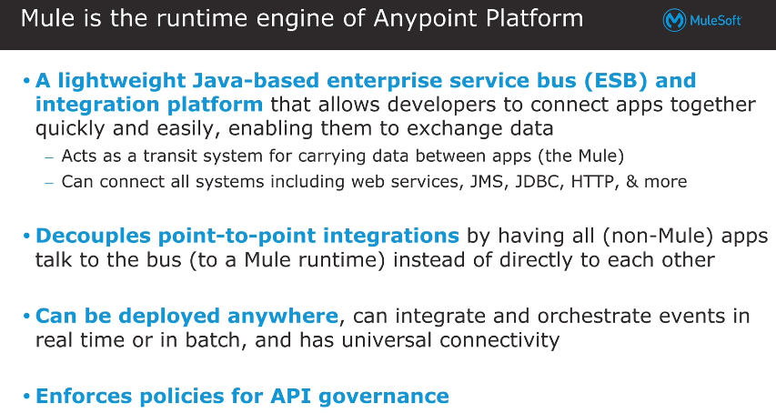

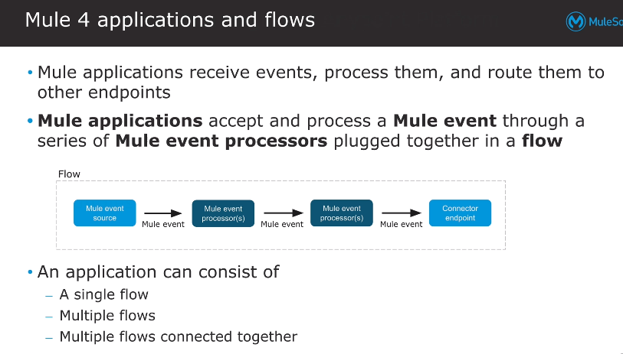

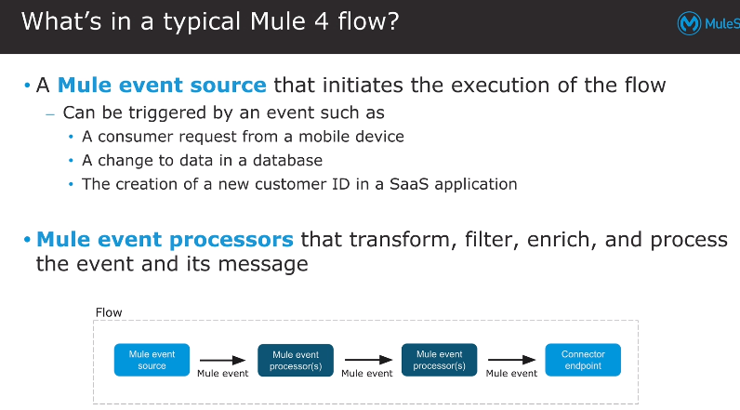 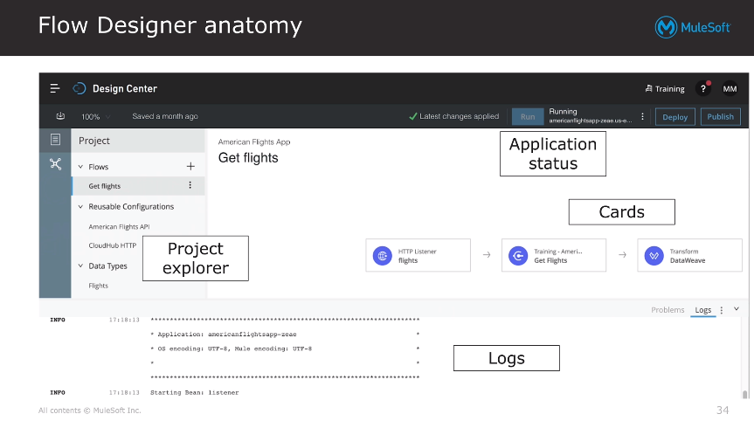

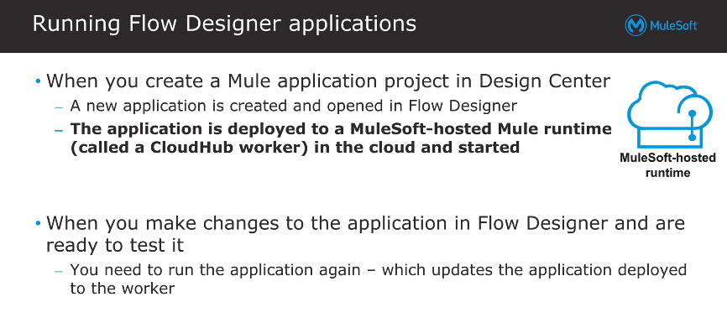

Note:-

1. Mule app created by flow designer needs to be deployed n tested to somewhere, where mule runtime is in a working condition since flow designer is a web-tool deployed on cloud so flow designer uses Cloudhub to deploy n test the mule app…but if we are creating the mule-app using anypoint studio then we are developing that mule-app inside our machine n we have already an instance of mule runtime that is used to deploy n test the mule app in local so we use anypoint studio’s inbuilt mule runtime.

Worker:

Worker is a place where your mule-apps are get deployed in Clodhub.Workers in layman term a VM or you can say a computer or laptop

As computer or laptops or VM comes with their diff. diff. configurations like 1gb ram,2gb ram,intel processor etc the same way we have worker size concept which is as below:

|  |
| --- |
| MICRO (default; 0.1 vCores) 500MB |
| SMALL (0.2 vCores) 1GB |
| MEDIUM (1 vCore ) 1.5GB |
| LARGE (2 vCores) 3.5GB |
| XLARGE (4 vCores) 7.5GB |
| XXLARGE (8 vCores) 15GB |
| 4XLARGE (16 vCores) 32GB |

When we say we have to scale up or scale down or scale vertically or scale horizontally that means

Vertical Scaling: increasing or decreasing the size of the vcore or worker..

Horizontal Scaling: increasing or decreasing the no of workers according to the situation

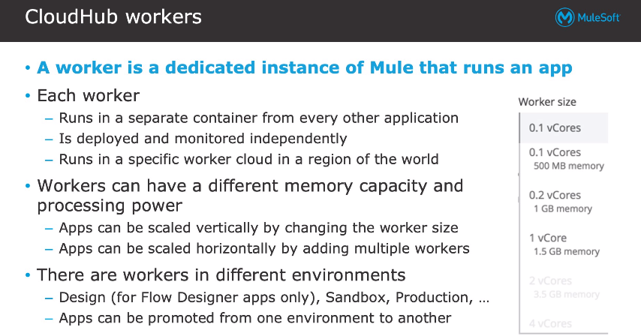

Mule Event:

As we already know, mule works on events so structure of an mule event is below:

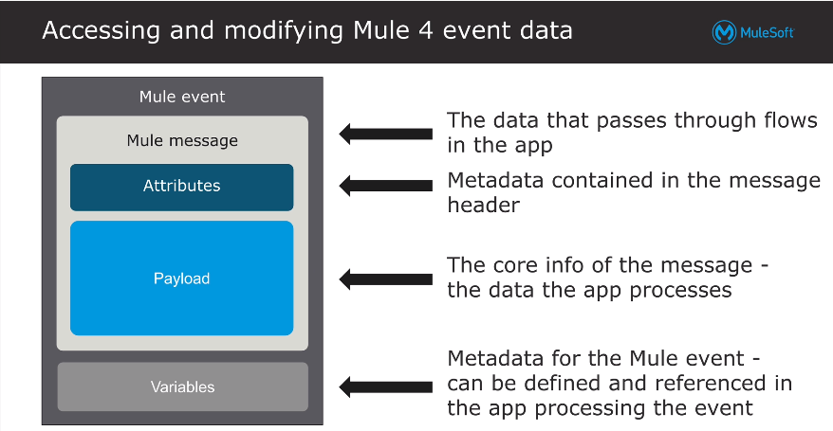

Dataweave:

Dataweave is the language used to access,query,filter the mule events.Currently we are using Dataweave 2.0.

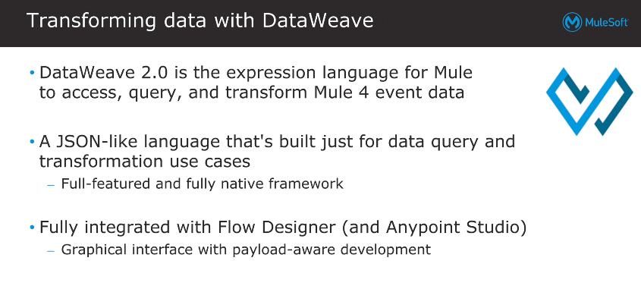

Transform Message:

Transform message component is a component that we can use to transform the mule events.

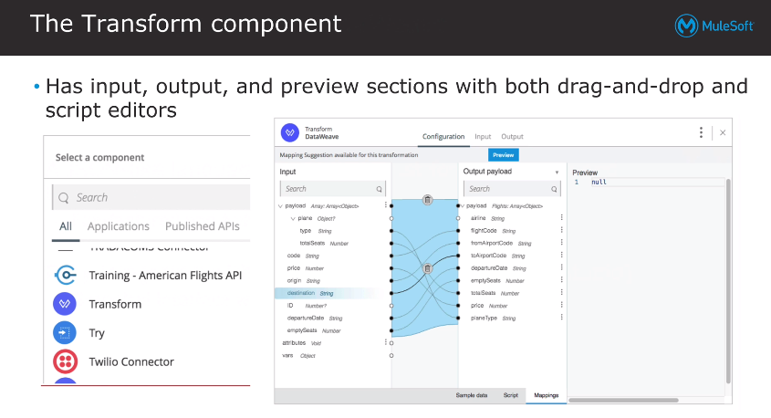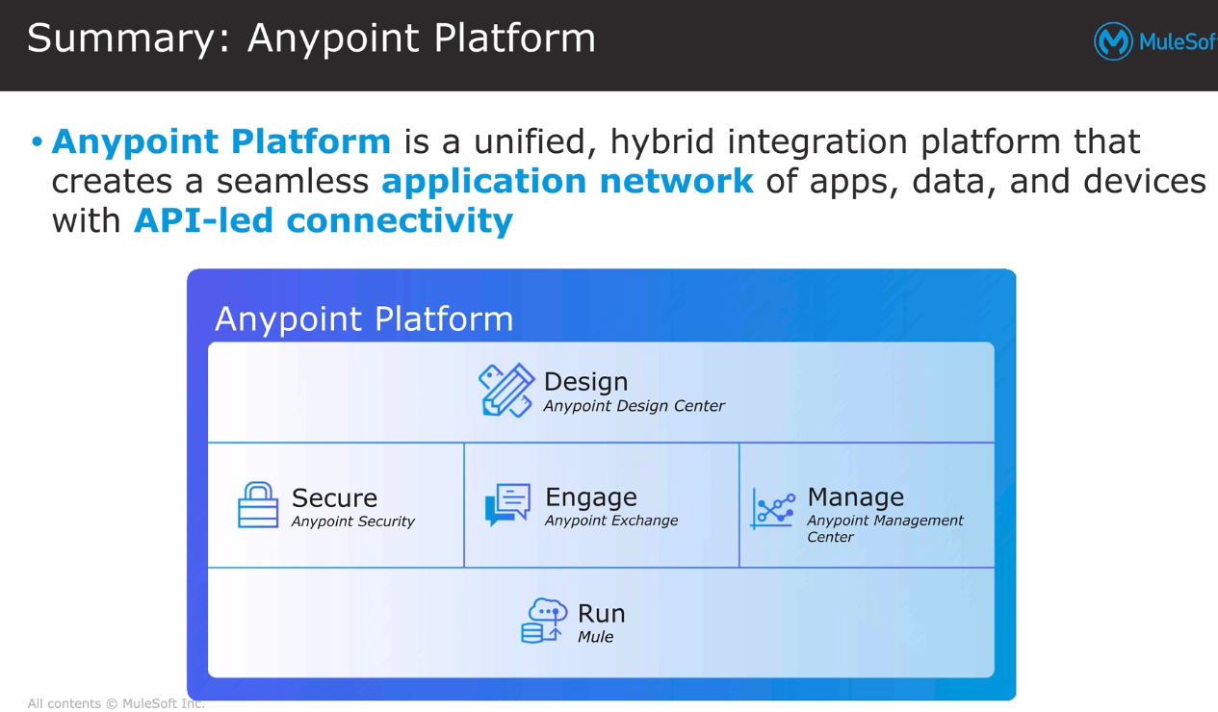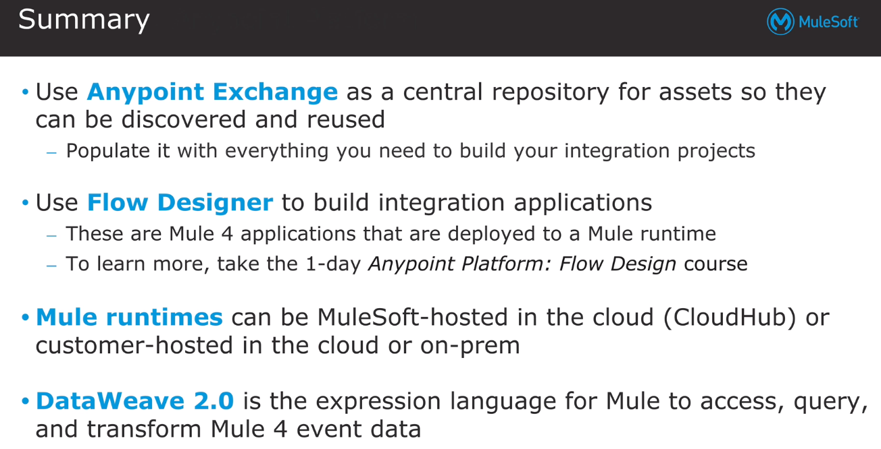

# 3 - Designing APIs

In this module ,we will start with actual usage of mulesoft by designing APIs which includes the Design stage(Design,Simulate,Feedback,Validate) of API Lifecycle process…

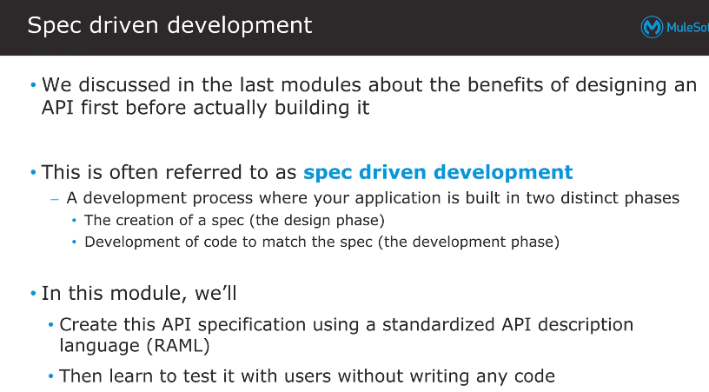

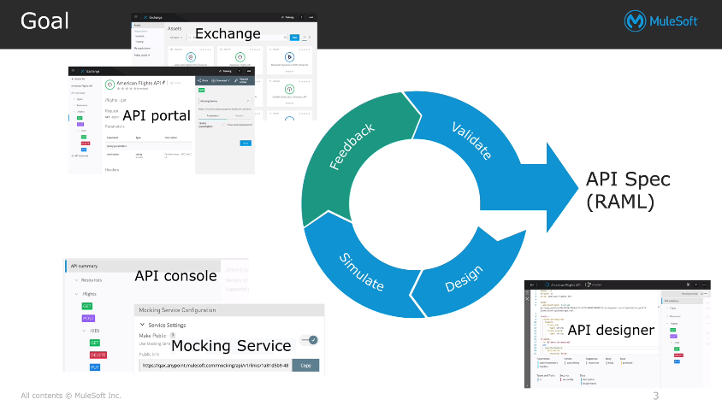

In Designing Phase,

we will use

API Designer: Used for creating the API Spec that describes the API behaviour

API Console: It provides the visual representation of API Spec developed n also involves Mocking Service which is used to test(Simulate) the API Spec developed.

Once API is developed n tested thoroughly, we need to publish the API in Anypoint Exchange so that the API is available for clients or others developers to test the API.As soon as we publish the API in Exchange,the Rest Connect creates API Portal for that API which involves Documentation,Mocking Service,API Console for all others to read n test the API.once client test the API Spec he validates the API spec n if all things are correct then that API Spec is finalized for next process otherwise again update Design with API Designer,testing with API console +mocking Service+Anypoint Exchange publish,API Portal is updation n cycle goes on until Client confirms Developed API Spec is as Expected.

Note:

1. When we publish the API in Anypoint Exchange,It publishes the Asset’s API Portal in Private Anypoint Exchange so to make API Portal Accessible for external clients or developers we should be creating Public API Portal..

API Specification:

The result of Designing phase Activity is API Specification….API Specification is a contract between API Consumer and API Provider which describes how the API behaves…For Designing API Specifications we can use RAML(Restful API Modeling Language) or OAS(Open API Specification).Currently we are using RAML v1.0 (which is based upon YAML(Yet Another Markup Language))..OAS supports both Json or YAML format

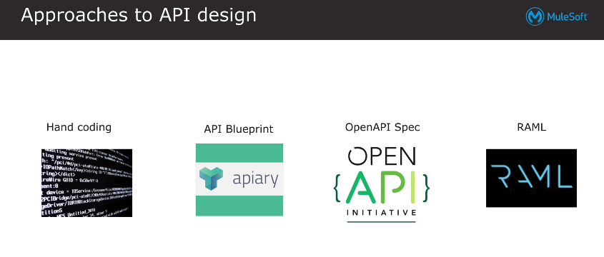

RAML:

RAML stands for Restful API Modeling Language.It supports YAML(Yet another markup language) n currently we are using RAML v1.0…RAML files can be used to auto-generate the documentation,mocked endpoints,interface for API Implementation etc.

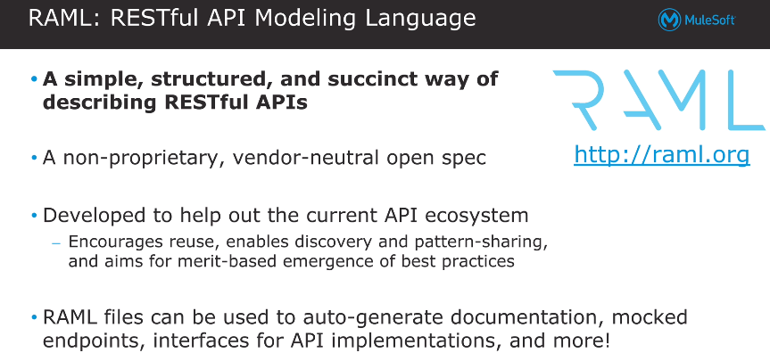

Example of a URL n what it can contains:-

[**https://www.google.com/search?q=RAML**](https://www.google.com/search?q=RAML)

**protocol://hostname/resource?queryparameters**

**https:// == Protocol**

[**www.google.com**](http://www.google.com)**/ ==hostname**

**search ==resource**

**?q=RAML == queryparameters**

Resources:

Resources are object that are part of URL, that you want to act upon.generally resources in RAML are identified by /resource-name + UriParameters is also a resource identified by /{resource-name}

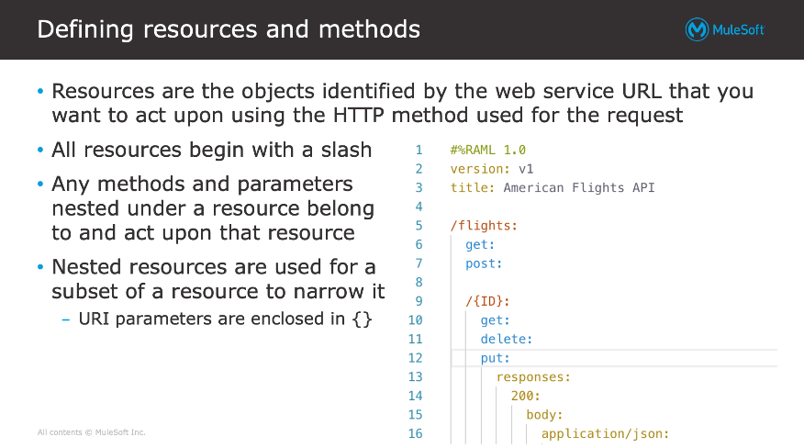

**Methods:**

**Documentation:**

**If we specify Documentation in main raml file then that documentation is shown at Documentation Tab in API Console->Documentation**

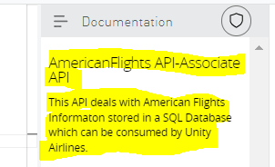

**QueryParameters:**

**UriParameters:**

**ResourceTypes:**

**Traits:**

**Library:**

**Examples/Example:**

**DataTypes:**

**API Console:**

**Mocking Service:**

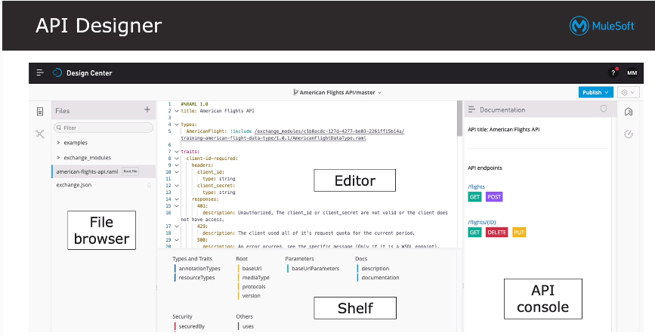

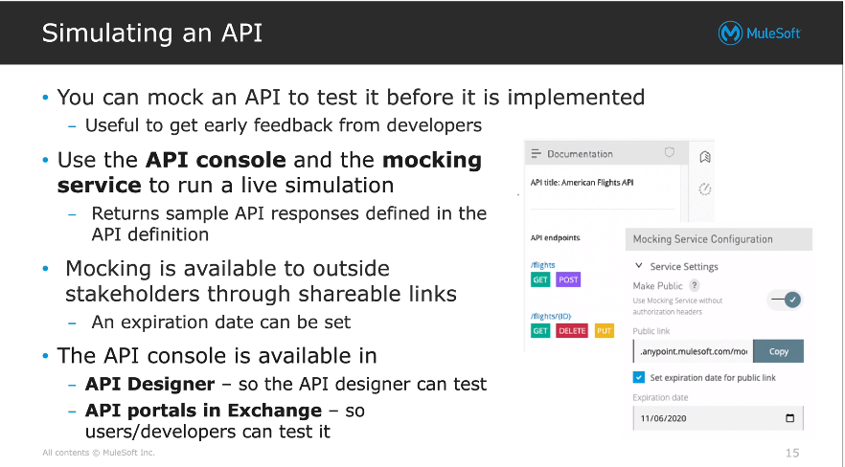

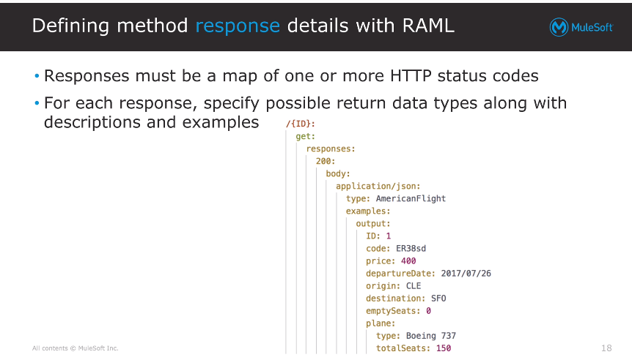 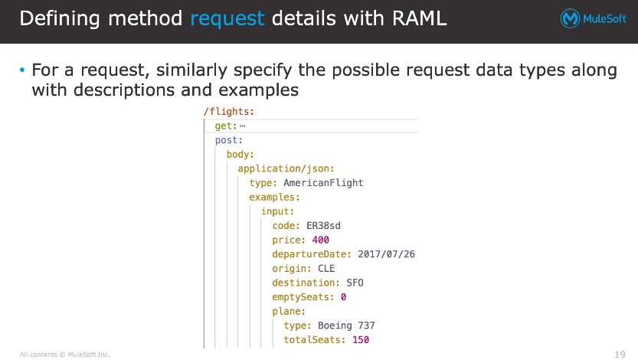 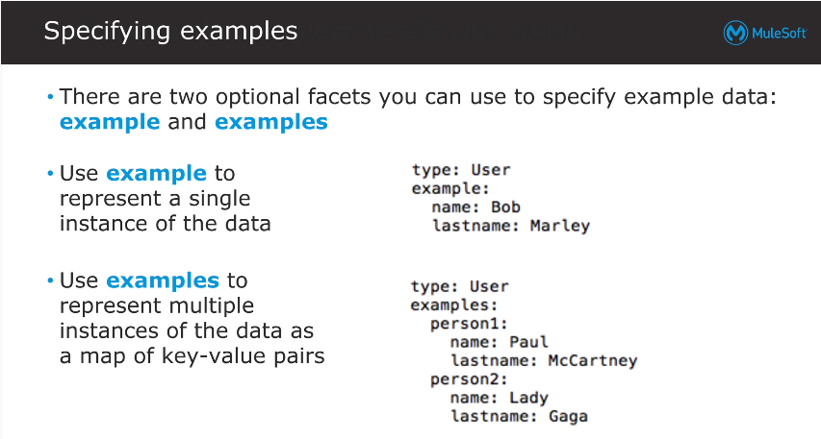

**Note:**

1. **If you just created “an /resource” endpoint n just specify the methods name (get,post,delete,put,patch) n no request or no response ,no queryparams no uriparams,no headers but if you test that endpoint u will get 200 ok message with {} empty object body**

